HOW TO GIVE STORE CREDIT OR REFUND
STEP : 1
Go to Superapp. Then click Records.
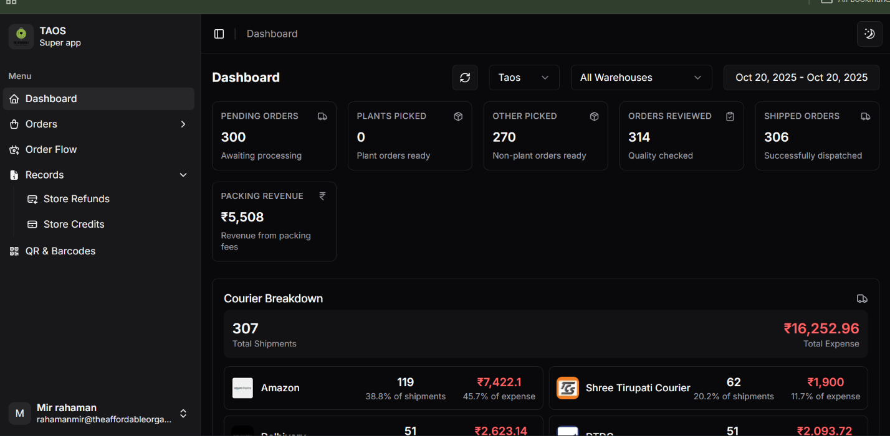
STEP : 2
For issuing store credit, click Store Refunds.
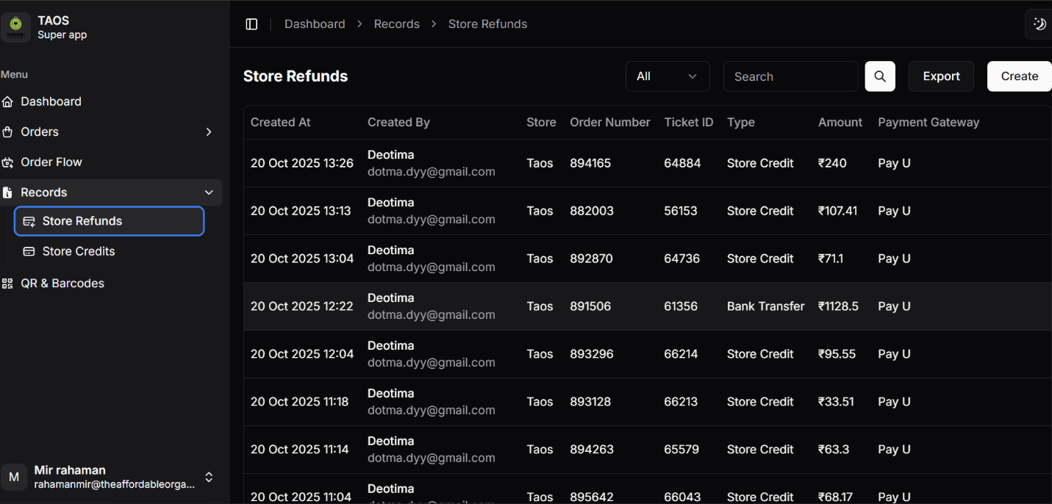
STEP : 3
Press Create at the top right to create record.
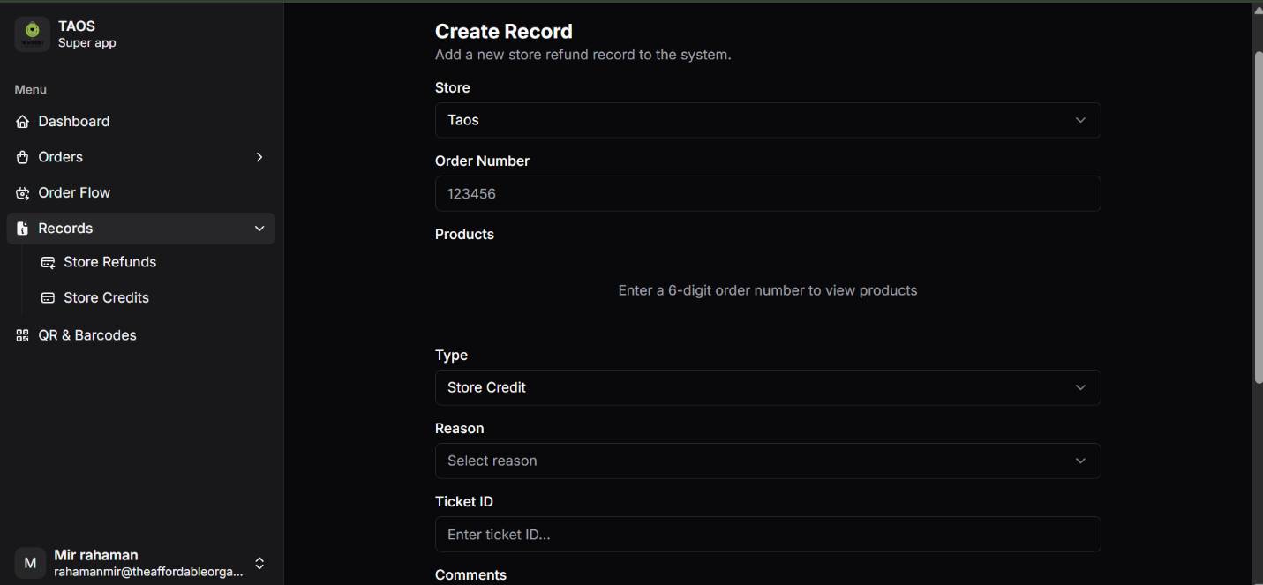STEP : 4
Insert order number. Select suitable reason (Damage, Missing, Delivery issue, Out of stock, mention other reason). Enter Ticket number. Type is Store credit.
** In case of Refund, select Type Bank Transfer.**
STEP : 5
Increase the quantity of only required products. It can’t go beyond available number.
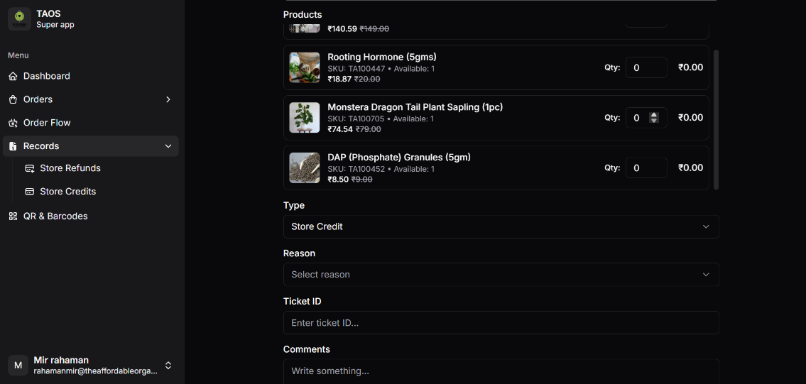
STEP : 6
In comments, mention this line –
Store credit of Rs._ is issued for _(Reason with product name).
**In case of Refund, write Rs._ is refunded for _(Reason with product name).**
STEP : 7
Upload the images the customer sent in ticket.

STEP : 8
Click Submit.
STEP : 9
After issuing store credit or refund, come to Sagepilot.
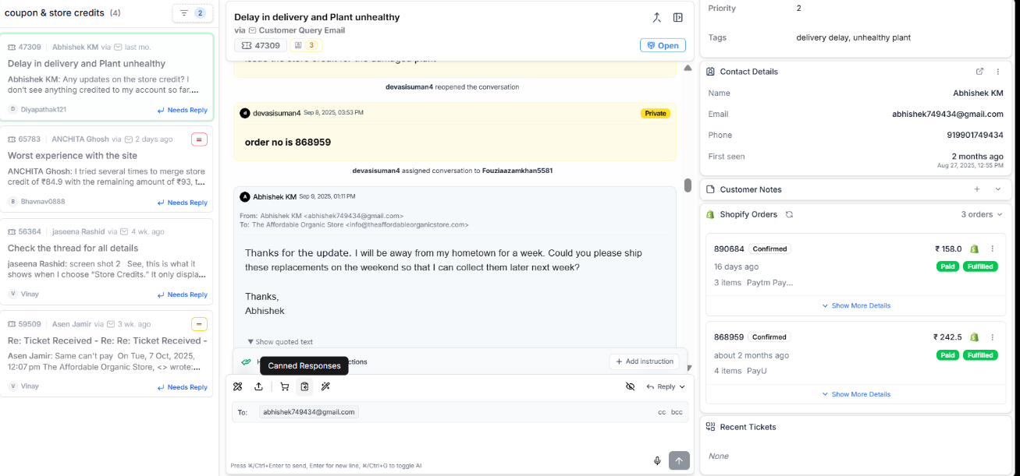
Search store credit or refund and forward this mail from canned response –
**For Store Credit**
Dear Customer,
We sincerely apologize for the damaged or missing products (mention product name) in your order. And we are pleased to inform you that we have initiated the refund in the form of Store Credit (of Rs._) for the damaged/missing products (mention product name) [excluding the discount applied during checkout] in your order. This credit will be reflected shortly in your Affordable Organic Store wallet balance. Kindly use it for your next purchase {paste customer email id}.

How to Use Your Store Credit
1. Log in to your account. {paste customer email id}
2. Add products to your cart.
3. Click Checkout once you're done.
4. Enter your Email for OTP verification.
5. After entering the OTP,
6. On the Payment page, choose Store Credit (4th option).
7. Place your order.
We truly appreciate your understanding and patience. Please feel free to reach out if you have any questions or need further assistance.
Warm regards,
The Affordable Organic Store Team
**Choose anyone between damaged or missing or mention other if any.**
**For Refund**
Dear Customer,
We sincerely apologize for the inconvenience caused by the issue. We understand how disappointing this must be for you, and we truly appreciate your patience and understanding.
We have initiated a refund of ₹ (mention amount) directly to your bank account. Please allow 7-10 working days for the refund to reflect in your account, depending on your bank's processing times.
If you do not see the refund after this period or face any issues, we kindly request you to contact your bank for further assistance.
For your reference and peace of mind, we have attached a PDF document as proof of the refund transaction.
Thank you for choosing The Affordable Organic Store. We are committed to ensuring your satisfaction and look forward to serving you better in the future.
Warm regards,
The Affordable Organic Store

